

**Database Systems**

**Lab No.6**

**Submitted By**

**Soha Ali**

**51169**

**Submitted To:**

**Ma’am Hafsah Mehmood**

**Task 1: Creating Database and Tables**

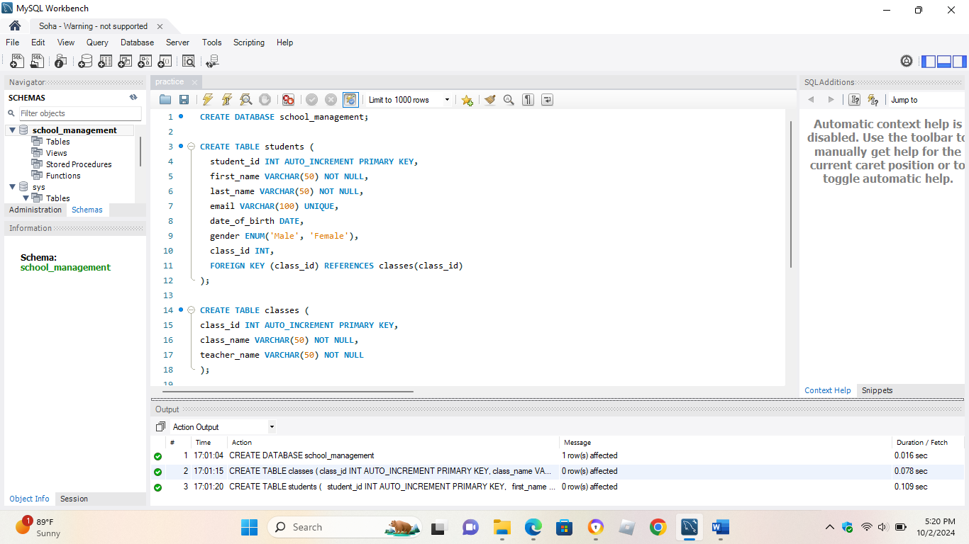

**Task 2: Altering Tables**

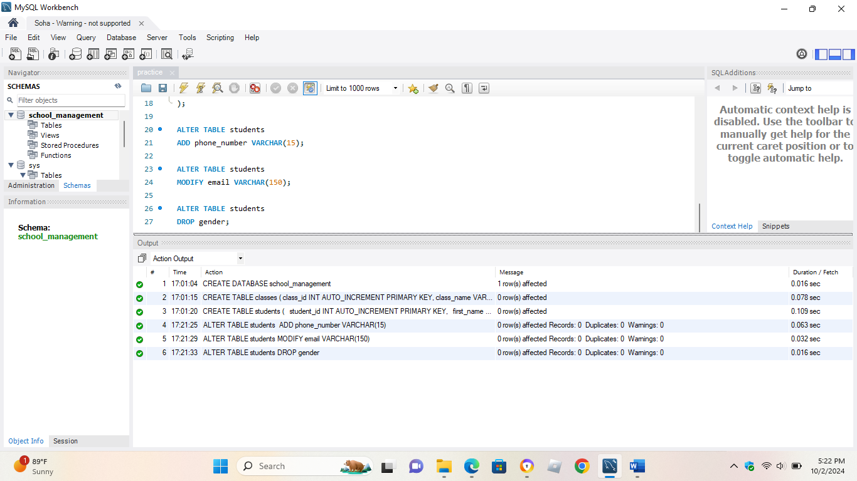

**Task 3: Dropping Tables**

